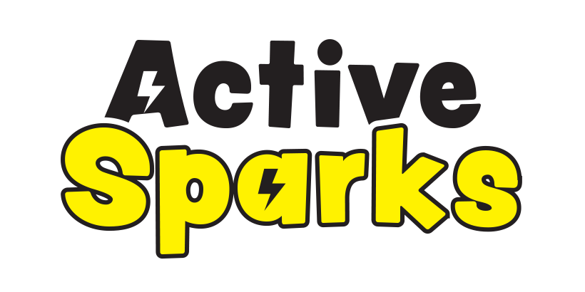
ACTIVE SPARKS
Terms & Conditions (updated September 2020)

- FEES, INVOICING AND PAYMENTS
1.1 Fees:
1.1.1 Fees are charged on a term rate.
1.1.2 Full payment must be made prior to the child starting the programme.
1.1.3 Confirmation of registration will be on receipt of the full registration fee and completed enrolment/registration form. Confirmation will be based on class availability.

1.2 Absences
1.2.1 ACTIVE SPARKS must be notified of any absences prior to the session.
1.2.2 ACTIVE SPARKS is not liable for any refunds once the child has been registered and payment has been received, as this confirms the child's place for the term.

1.3 Invoicing
1.3.1 ACTIVE SPARKS will send an invoice upon confirmation of availability in the programme
if requested by the customer.
1.3.2 A child’s place is considered ‘unconfirmed’ until payment and the registration form is complete.

1.4 Payment
1.4.1 ACTIVE SPARKS’ preferred method of payment is electronic transfer via internet banking.
1.4.2 For ECE services and community classes - All payments should be made to J M McLean
(*unless the programme is being organised through an ECE service, which then may establish a different payment system).

Payment Details:

Account Name: | J M McLean  ACTIVE SPARKS
Account Number: | 06-0556-0957254-00
Reference: | Child’s Full Name (and)  Community Class (CC) Or Pre-school Initials (eg IT)

2. SAFETY & BEHAVIOUR
2.1. A parent/caregiver (or ECE centre staff member) must be present at all times during the scheduled programme sessions.
2.2 Parents are required to be in attendance at all times throughout the sessions (unless the programme is being held at a ECE centre). If for some reason you are not present, in the event of an injury you (parent) authorise ACTIVE SPARKS (ECE staff member) to administer or approve any medical treatment deemed necessary to the participant.
2.3 ACTIVE SPARKS works hard to deliver safe sessions, however if your child was to incur any medical expenses or injuries during any of its programmes, ACTIVE SPARKS does not accept liability.
2.4 ACTIVE SPARKS accepts no liability for any property the child/ren bring with them to the programme which is lost or damaged while attending the programme.
2.5 All children are expected to adhere to ACTIVE SPARKS safety and behaviour rules, and must follow staff members instructions.
2.6 You are required to inform ACTIVE SPARKS of any medical conditions your child may have. Pre-existing medical conditions must be disclosed on the ‘registration/payment form’ prior to the programme beginning.
2.7 Due to the nature of the programme the staff delivering the programme may need to make physical contact with your child to support their learning. If you have concerns with this please notify ACTIVE SPARKS.

3. INFORMATION & DATA
3.1 The information and date which is provided within your child’s enrolment form will be held on computers and in manual records for Janna McLean only. No information and data will be given or shared with other parties.

4. DISCLAIMER:
4.1 ACTIVE SPARKS reserves the right to cancel any of its sessions or events at any time, due to weather conditions and unforeseen circumstances (ie pandemic). ACTIVE SPARKS will endeavor to notify parents/teachers as soon as possible via text and social media and will attempt to schedule a catch-up session if possible.

4.2 ACTIVE SPARKS may take photographs and videos of children within the session time for business purposes such as but not limited to the ACTIVE SPARKS website and social media accounts. If parents/caregivers have concerns with this, they must notify (in writing) to ACTIVE SPARKS or the ECE service prior to the programme beginning.
5. COVID-19:
5.1 Customers (parents, teachers and children) are required to hand-sanitizer prior to and on completion of the session.
5.2 If your child (or their siblings/parents accompanying the child to the session) is unwell we ask that you refrain from coming to the session until the signs/symptoms are not present or until doctors have given clearance.
5.3 To allow for social distancing (during Level 3-4) we ask that only one parent/guardian accompanies the enrolled child to the session and if possible, additional siblings are not present.
5.4 During this period there is to be no sharing of drinks or food.
5.5 During this period Active Sparks will not be able to supply any extra toys (another than the required equipment) in the sessions.
5.6 If children/parents/caregivers/teachers/staff notice any spillages/vomit they must notify a staff member immediately and they will clean it up with disinfectant.
5.7 If parents/children require the use of the toilet during the session it is recommended that only one parent and their child attends the toilet at a time to prevent crowding in the toilet areas in public locations.
5.8 During Level 3-4 parents are required to contact trace for community classes. We suggest using the Government Tracing App, however you are also able to use the Community Centre QR code or Active Sparks QR code.
5.8 During Level 3 social distancing of 2m is recommended. During sessions a 1m distancing is recommended. Where possible children will keep a 1m distance and equipment will be spaced out in the area to accommodate this.
5.9 ACTIVE SPARKS will not be able to operate in Level 2. If 80% of the sessions have been completed then ACTIVE SPARKS is not required to refund the remaining sessions.

